MAXIFS function is a statistical function. This function returns the maximum value based on one or more than one conditions from the specified cells. This function was introduced in MS Excel in 2016. The purpose of this function is to get the maximum value with the criteria given.
Syntax
The syntax for this function is as follow
= MAXIFS(max_range, criteria_range1, criteria1, [criteria_range2, criteria2], ...)
This function has following arguments –
- Max_range – This is a required argument. This is the actual range of cells from which the maximum shall be determined
- Criteria_range – This is a required argument. These are the set of cells to be evaluated with the criteria.
- Criteria1 – This is a required argument. Here, we would give a number, expression, or text that defines which cells will be evaluated as maximum.
- Criteria_range2 – An optional argument wherein we can specify the additional ranges & their associated criteria.
Excel allows to put in upto 126 criteria’s
How to use MAXIFS function
It is a built-in function which can be used as worksheet function in Excel. To understand the uses of this function and how it can be used let’s consider few examples-:
Example 1
Suppose we have quarterly expenses of three regions in which our business operates. We wish to find out the maximum expense for North region so let’s see the formula to be used -:
=MAXIFS( $D$5:$D$33, B$5:B$33, "North")
In this example, the Excel MAXIFS function identifies rows where the value in column B is equal to North, and returns the maximum value from the corresponding values in column D.
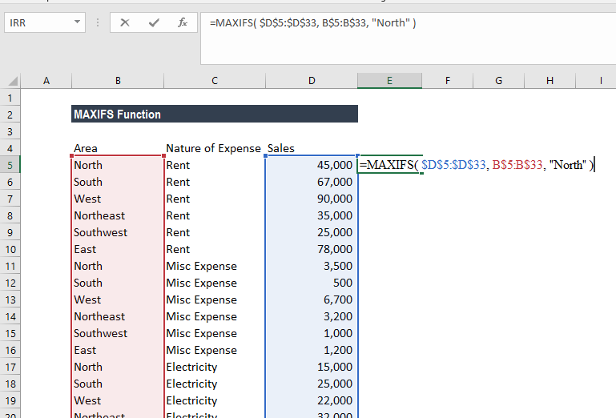
I.e. the function finds out that the maximum value is rent expense which is 45,000.
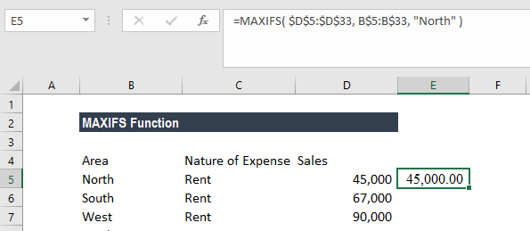
Example 2
Let’s continue with same example, we wish to know which region had highest printing & stationary expense.
The formula to be used would be
=MAXIFS( $D$5:$D$33, C$5:C$33, "Printing & Stationary" )
The formula would return the amount that have highest expense of Printing & stationary.
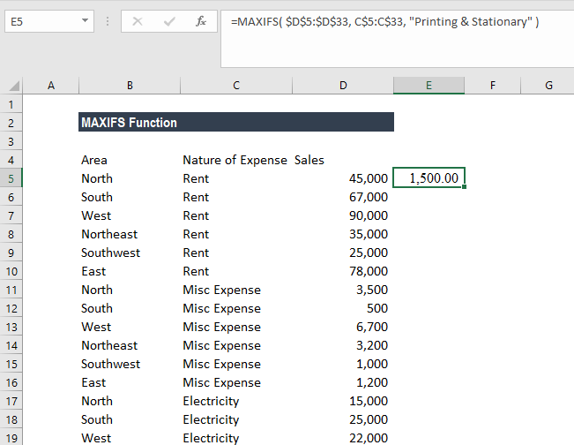

Example 3
Let’s take this example, we wish to find out the student who have scored distinction in any subject and the marks scored are maximum.
So, we have the following data given –
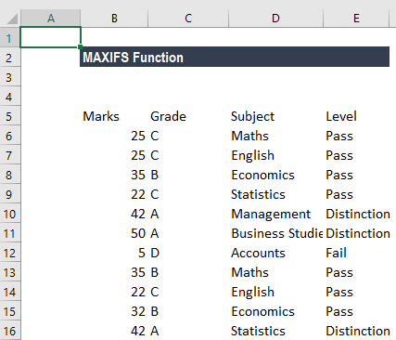

The formula we shall use would be =MAXIFS(B6:B16,C6:C16,"A",E6:E16,"=Distinction")

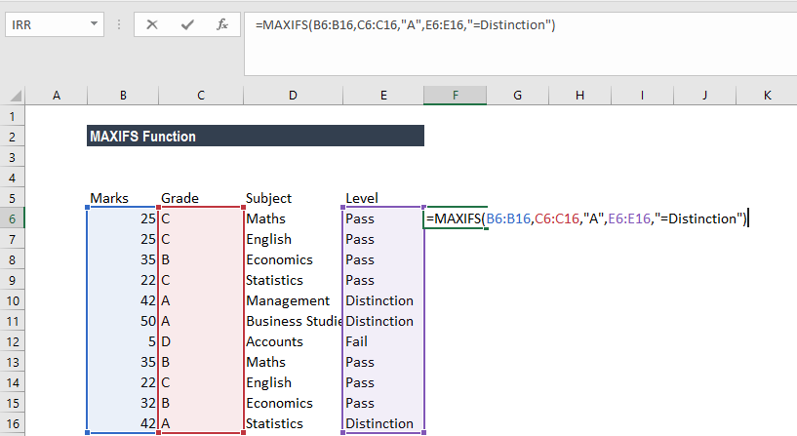

In criteria_range1, C10, C11, and C16 match the criteria of "A" Of the corresponding cells in criteria_range2, E10,E11 and E11 match the criteria of Distinction. Finally, of the corresponding cells in max_range, B11 has the maximum value. The result is therefore 50.

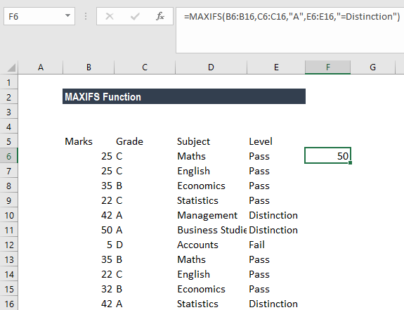

Example 4

Let’s take this example wherein we would use MAXIFS with array formula. We wish to use "MAXIFS" formula that will return the latest date for open tasks for each project, in Column F for below given data.

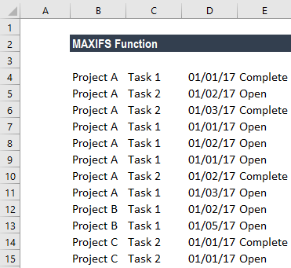

So, for the data example above, we would expect to see 01/03/2017 in Column F on all rows for Project A; 01/05/2017 for all rows of Project B; and 01/01/2017 for all rows of Project C.

The formula to be used is
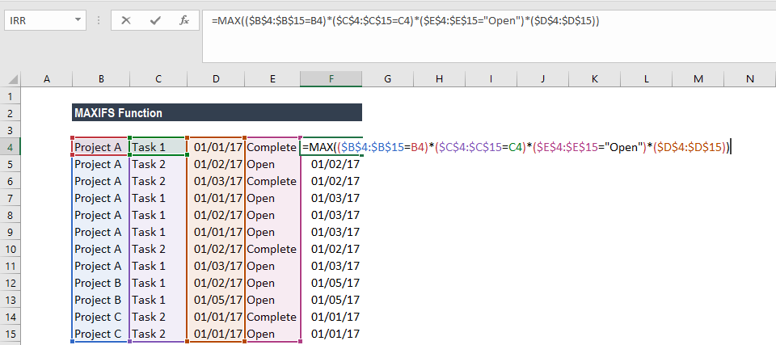

For parentheses, we need to press Control+Shift+Enter the first time we input it because it only works as an array formula, but after that we can drag it over the range you need it.
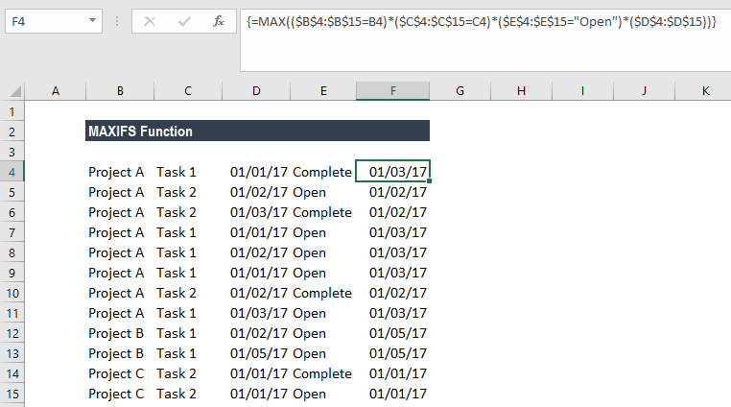

Things to remember in MAXIFS function

- #VALUE! Error - This error is returned when size and shape of the max_range and criteria_rangeN arguments aren’t be the same.
- If we are using earlier versions of excel then we can use an array formula based on MAX and IF to find minimum values with criteria.
- #NAME? Error – This error occurs when we are using an older function of Excel.
- MAXIFS will include rows which are hidden

