ISREF function is categorised under information function. This function shall test if a given value is a reference or not. If the given value is reference it shall return TRUE else FALSE.
Wile doing financial analysis let’s assume we have to create 21 worksheets in a workbook. All 21 worksheets have a name assigned to it. These are monthly reports that go to management. Hence, in order to avoid missing any of the sheet we can use this function and keep a track of it.
Formula
The formula for this function is as follow
= ISREF(values)
This function has only one arguments -:
Values – It is a required argument. It is the given value or expression that we wish to test.
How to use ISREF function
ISREF function is a built-in function in Excel and can be used as a worksheet function (WS) in Excel. As a worksheet function, this function can be entered as part of a formula in a cell of a worksheet.
To understand the uses of this function and how it can be used let’s consider few examples-:
Example 1
Let’s see few examples to understand how this example works -:
Formula | Result
=ISREF(A1) | TRUE
=ISREF(A1:A2) | TRUE
= ISREF(A1:D4) | TRUE
=ISREF(“Text”) | FALSE
=ISREF(A1*A2) | FALSE

The result we get -:
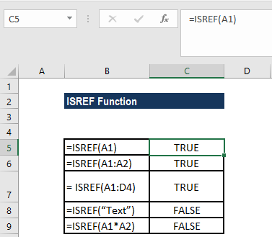

In cell B9 we have provided expression A1*A2 which would return a value that is a product of the values in two cells. Hence in this case the ISREF function shall return FALSE.
Example 2
Let’s now see how to test if a worksheet name exists in the worksheet. To do that we can use a formula that is based on the ISREF and INDIRECT functions. Suppose we want to find out if following worksheets exist or not -:
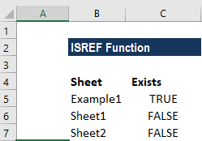
For finding out that, the formula taken is : =ISREF(INDIRECT("sheetname"&"!A1")) as shown below -:
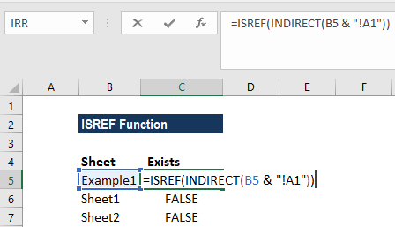

The result we get is -:
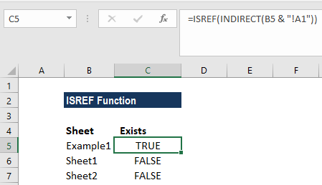
The ISREF function used here would returns TRUE for a valid worksheet reference and FALSE if it is not.
In this case, as we want to find out a particular sheet if it exists in a workbook or not, so we have constructed a full reference by concatenating the sheet names in column B with an exclamation mark and "A1":
B5 &”!A1”
This returns the text: “Example1!A1!” This text goes into the INDIRECT function. INDIRECT then tries to evaluate the text as a reference.
When INDIRECT succeeds, the reference is passed into ISREF which returns TRUE. When INDIRECT can't create a reference, it throws a #REF error, and ISREF returns FALSE.

